Introducing
realTime 2000

User Guide for realTime 2000 development kit

ACT Software

Contents
Welcome 3
What’s on your realTime screen? 3
Setting up realTime 2000 4
The Basics 5
Getting started with realTime 2000 5
Set the working directory 5
Creating the main class 6
Open a java file 7
Create a new class 8
Getting help 9
Shutting down realTime 2000 11
Testing the output files generated using Visual Café 12
Create a new project 12
Adding an existing file to a project 13
Deleting a file from a project 14
Running a project 15
Setting project options 16
Closing a project 17

Welcome

What’s on your realTime screen?

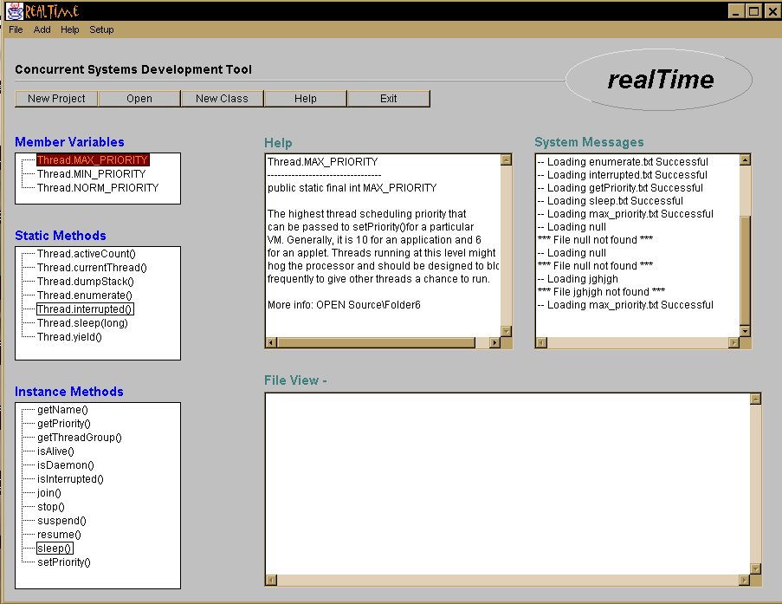

Thread API tree
The thread API is split into three sections. There are member variables, static methods, and instance methods. For more information select each item with the mouse.

Selecting Item
- Place mouse pointer over item to be selected.
- Select item by double clicking the select button on the mouse.

Thread API help area
This help area is dedicated to displaying help on the thread API. The scroll bar is available if text goes off the page.

System messages
This text area keeps you informed of what the system is doing, whether a file has loaded successfully or failed in execution.
File view
File view is a text area that displays text files. These text files are opened from the open file dialog box.

Toolbar functions

Create main class
Creates the main java file, which can either be a standalone application or an applet.

Open
Opens any text file in any directory using the open file dialog box.

New Class
Creates a new class file with it’s own methods and attributes.

Help
Opens a much more detailed help system that covers the following topics.

- Creating the main class
- Adding a new class
- Thread introduction
- Thread examples

Exit
Closes the system down

Setting up realTime 2000

- Insert Set-up disk in a floppy disk drive
- Select the realTime directory
- Copy realTime directory to it’s new destination

The Basics

Getting started with realTime 2000

Program execution

- Open the realTime directory
- Execute file ‘concurrency’ with a double mouse click

Set the working directory

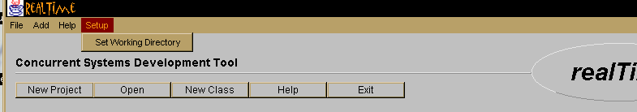

Menu selection

Setup

Set working directory

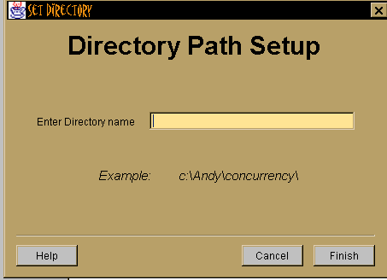

Directory Path Set-up
A directory name is needed for the program to locate the help files. Enter the full directory path of where the main program lies.

- If there is no flashing cursor in the text field, select area with mouse pointer.
- Enter directory name.
- If correct select the finish button.
- If details incorrect, select the cancel button.

Creating the main class

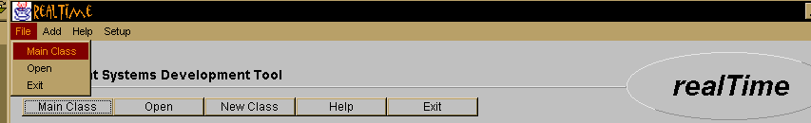

Menu selection
- File

Main Class

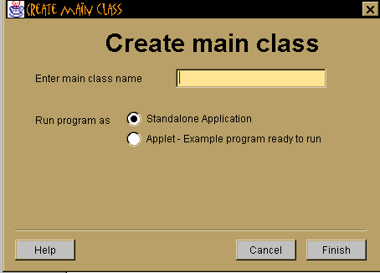

Create main class
Is responsible for creating the main class.

- If there is no flashing cursor in the text field, select area with mouse pointer.
- Enter class name.
- To answer the other questions, simply place the mouse cursor over the answer and press the select button.
- If details are correct select the finish button.
- If details incorrect, select the cancel button.
- Still have problems? Select the help button.

Open a java file

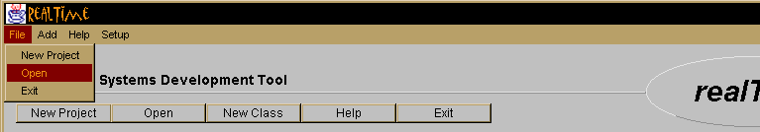

Menu selection

- File
- Open

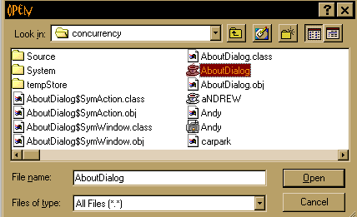

Open
Is responsible for opening class files.

- Select required directory.
- Select required file with mouse pointer.
- If correct file selected, select finish button.
- Cancel operation? Select the cancel button.

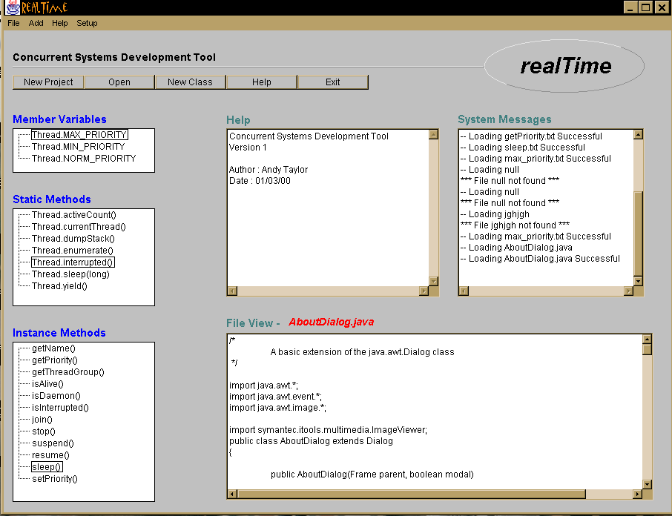
The opened file is
displayed in file view
File name is
displayed

Create a new class

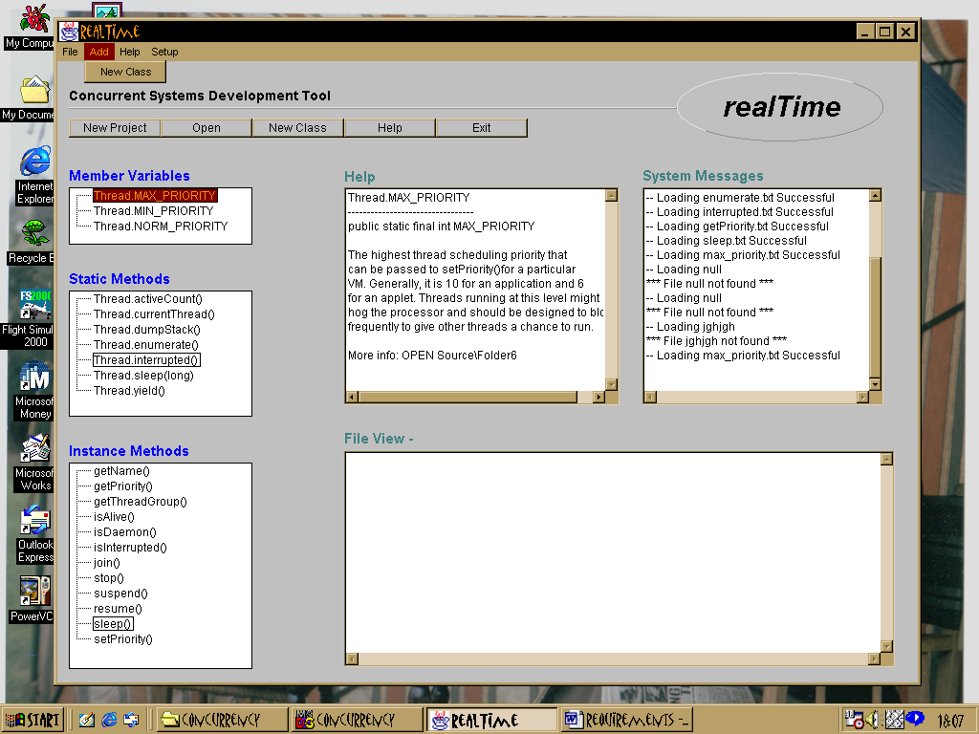

Menu selection
- Add
- New Class

New Class

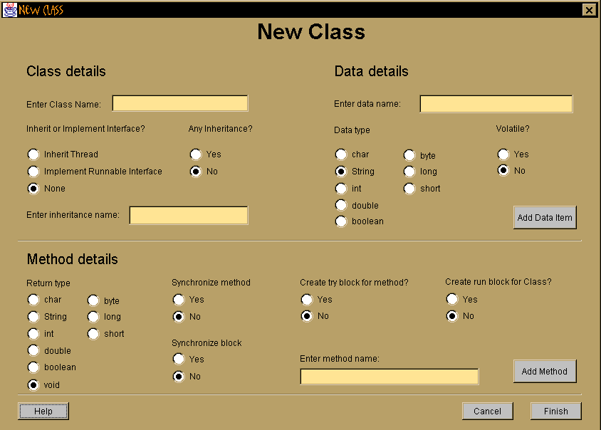

Class details

- Enter class name - Each class will be written to a separate file. The name of the file is taken from the class name
- Thread class or normal class - If it is a thread class, it will either inherit class thread or implement a runnable interface.
- Any Inheritance - Does the class inherit from another class?
- Enter inheritance name – check you are not inheriting thread

Method details
- Enter method name
- Return type – void, int, char, string etc.
- Synchronize method? – Are you accessing or changing data?
- Synchronize method
- Synchronize block
- Try block – do you wish to create a try block for this method?

Data details
- Enter data name
- Private or public
- Data type – int, char, string etc.
- Volatile – protects data by rereading value from shared memory

Getting help

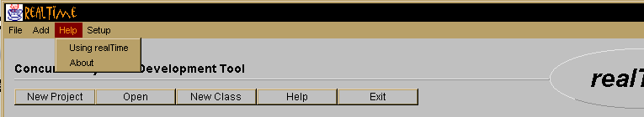

Menu Selection

- Help
- Using realTime
- About

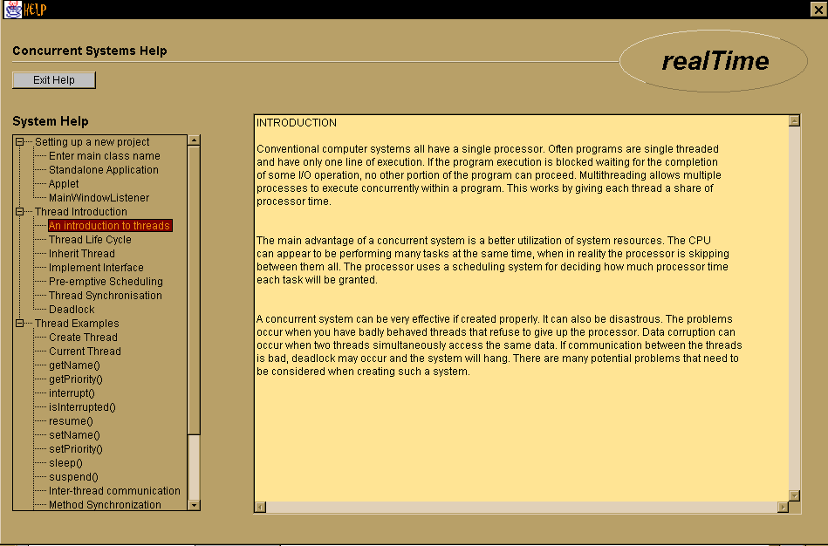

Using realTime
Provides help on a number of different topics relating to the implementation of real time systems.

- Place mouse pointer over item to be selected.
- Select item by double clicking the select button on the mouse.
- Information on the topic will be displayed within the text area to the right of the screen.
- If the information is not displayed, ensure the working directory has been set-up and the system help files have not been removed from the realTime directory.

About realTime

Display information about realTime.

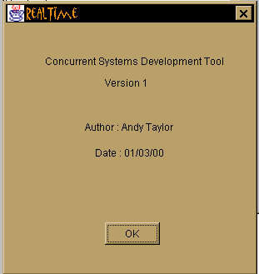

Shutting down realTime 2000

There are three methods of shutting the program down.

- Use the menu system. Go to ‘File’ and select ‘Exit’.
- Use the toolbar. Select the button named ‘Exit’.
- Close realTime by selecting the cross in the top right hand corner of the window.

Testing the output files generated using Visual Café

Create a new project
All Java programs created in Visual Cafe must be part of a Visual Cafe project; otherwise, Visual Cafe cannot compile and run them. A project also helps you manage and organize your files as you develop your Java programs.

1. Choose File New Project.

The New Project dialog box displays.

2. Select the project template you want as the base for the new project.

The default template is indicated by an asterisk. You can easily change the default template by selecting a template and clicking Set Default.

3. Click OK.

A new Project window opens with the selected template loaded. All objects in the template are added to the project. Only one project displays in a Project window.

4. To save the project, choose File Save As.

The Save As dialog box displays.
The project and all of the files contained within it should be in the same directory. For easier project management, you should save each project in its own directory.

5. Select a directory and type the project name in the File name field, then click Save.

The Visual Cafe project file must have the extension vep. If you type just the first part of the file name, Visual Cafe will add the vep
extension for you.

6. Set project options as needed.

Often, the defaults provided with your project template are sufficient.

Details on this step

Note

· In Visual Cafe 1.0, you opened a project by opening the vpj file. In Visual Cafe 2.0, you open a project by opening the vep file.

· The first time you save a project, all of the files it contains are saved to the directory you specify. After you save a project once, saving just the project does not save other files, such as applets. Use File Save All to save all files in a project.

Reprint permission by Symantec Corporation, Visual Cafe 1997

Adding an existing file to a project

To add files from the Visual Cafe environment

1. Choose Insert Files into Project.

The Project Files dialog box displays.

2. Select the file(s) that you want to add.

3. Click Add or Add All, as appropriate.

4. Click OK.

The file(s) appear in the Project window.

To add files from the Windows Explorer or other file system window

· Drag Java or HTML files from the Explorer into the Project window.

To add files from the Find in Files dialog box

You can easily add a large subdirectory to your project using this technique.

1. Choose Search Find in Files.
2. Specify a directory.
3. Click Find.
4. Right-click on the window with the list of files. Then choose Add All to Project.

Reprint permission by Symantec Corporation, Visual Cafe 1997

Deleting a file from a project

As you are developing your project, you can delete HTML and Java source files as needed.

To remove a file by pressing DELETE

· In the Files view of the Project window, select a file and press DELETE.

To remove files by using the Project Files dialog box

1. Make the Project window active.
2. In the Packages or Files view, right-click the window to display the pop-up menu, then choose Insert/Remove Files.

Or while any view is displayed, choose Insert Files into Project.

3. In the Project Files dialog box, select one or more files from the list at the bottom pane of the dialog box.
4. Click Remove.

5. Click OK.

Note

· When you remove a Java source file from a project, all associated visual elements that are created in the Java code are also removed.

· Deleting a file from a project does not delete it from the project directory. You must manually delete it.

· You cannot remove imported files.

Reprint permission by Symantec Corporation, Visual Cafe 1997

Running a project

You can compile and run a project any time during its development cycle. Visual Cafe automatically saves files in the project before running.

· Choose Project Execute to run the project without the debugger.

· Choose Project Run in Debugger to run the project and start the debugger.

Important Before running in the debugger, make sure your project options are set to debug. When you are ready to compile your final program, make sure the project options are set to final. See Specifying whether builds are debug or final for more information.

Reprint permission by Symantec Corporation, Visual Cafe 1997

Setting project options

To run an application from within the Visual Cafe environment, you must specify the starting point of your application (the Java class file containing the main method) so Visual Cafe knows how to run your application. If you started a project with the Basic Application template or inserted a Java file that already had a main method in it, the main class was already specified for you. If there is no entry in this field, Visual Cafe tries to use the base project name or, for a native Win32 application, the base executable name (specified in the application name field).

1. Activate the Project window of the project you want to work with.

2. Choose Project Options.

3. In the Project Options dialog box, click the Project tab.

4. Select Application, if needed, then type the name of the class file in the Main Class field; for example, Frame1 or Frame1.class are both acceptable. If the class is inside a package other than the Default Package, you need to type package_name.
class_name in this field.

You can enter one name only.

5. Click OK.

The change takes effect the next time you run your project.

Note If you rename a class that appears in this field, Visual Cafe updates the field for you.

Reprint permission by Symantec Corporation, Visual Cafe 1997

Closing a project

When a project closes, all windows associated with the project close (except the Property List, which clears).

To close the active project

· Choose File Close while the Project window is active.

You are prompted to save any unsaved changes. Visual Cafe remains open so you can work on other projects.

To close all projects and exit Visual Cafe

· Choose File Exit.

You are prompted to save any unsaved changes. The project and Visual Cafe close.

Reprint permission by Symantec Corporation, Visual Cafe 1997

